Service Get- Alarms/{id}
Eg- Alarms/7
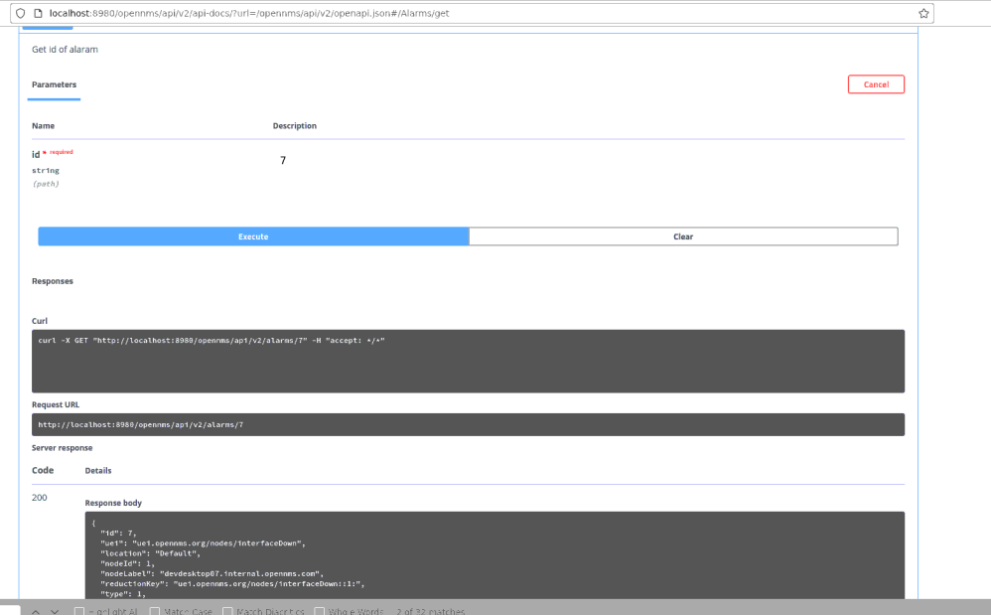

Eg – Alarms/78 (invalid id)
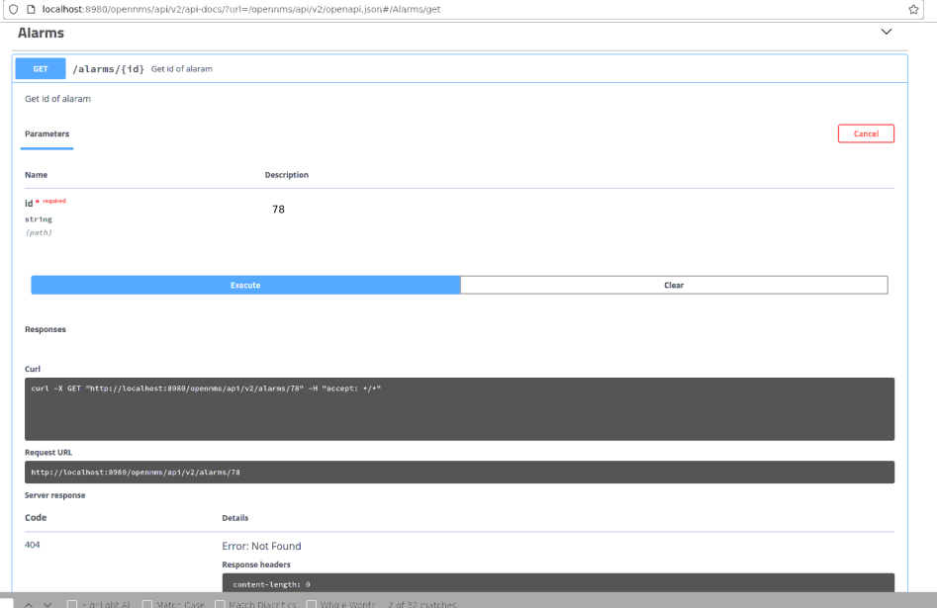

Service put Alarms/{id}
Eg – Alarms/7

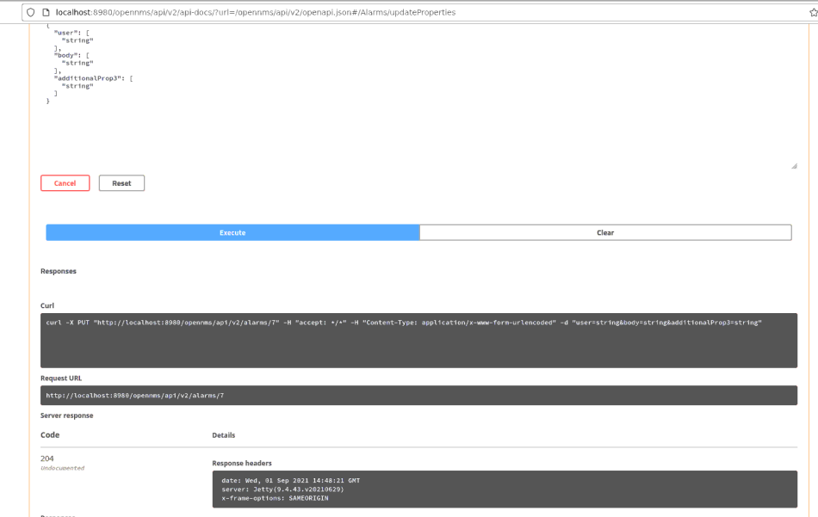

Service Delete Alarms/{id}
Eg – Alarms/43

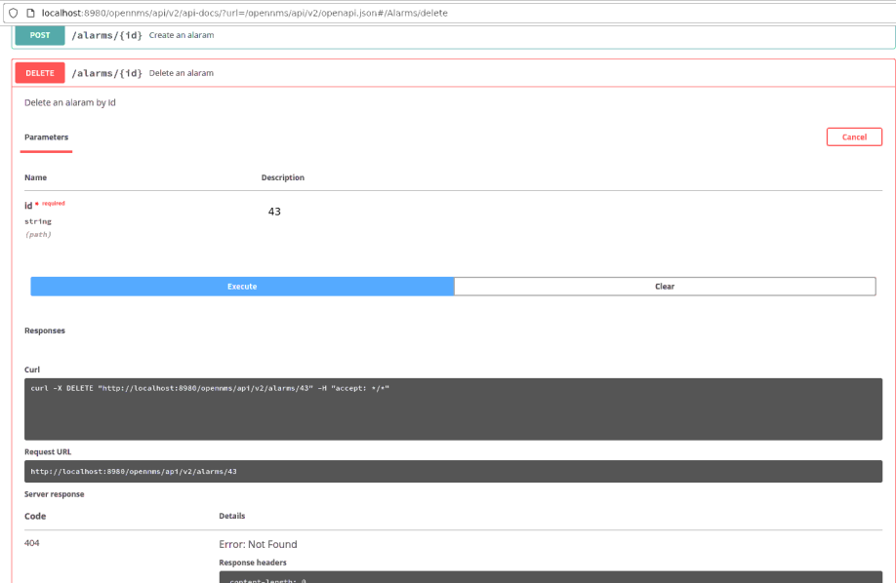

Service Get /Alarms

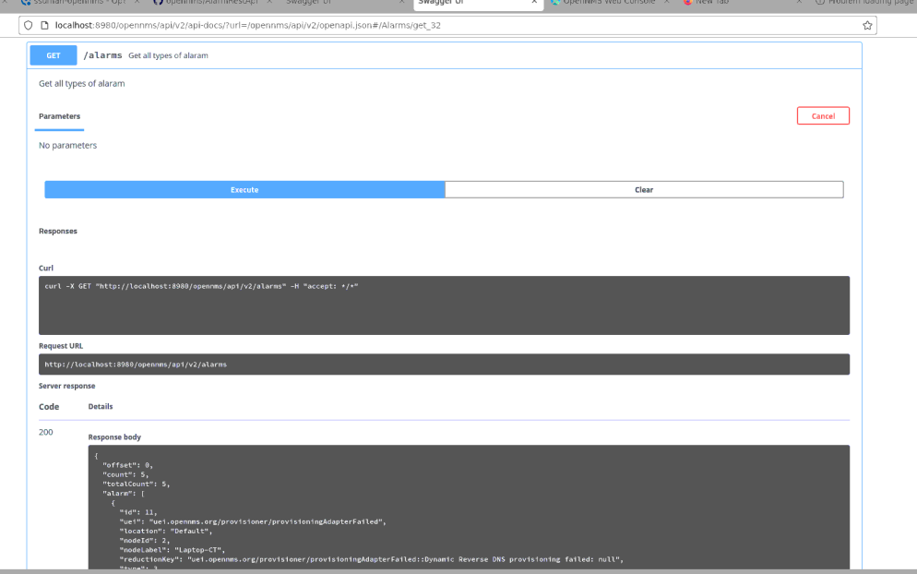

Service Alarms/count

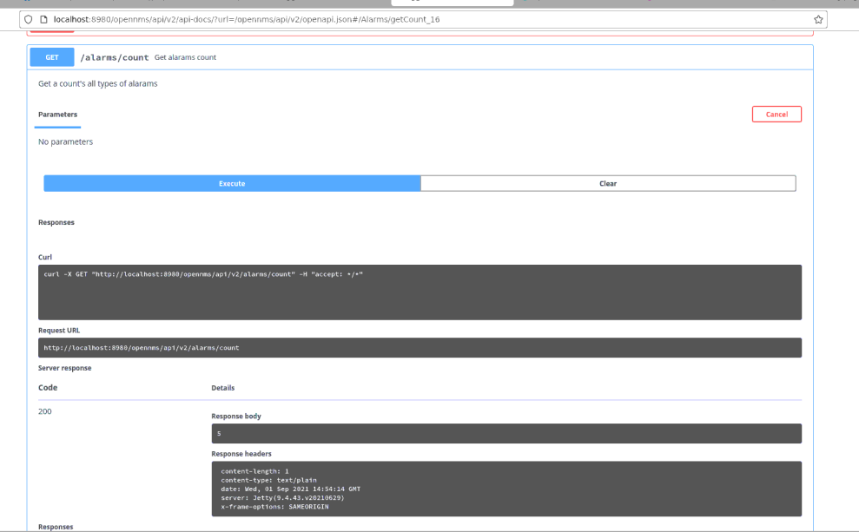

Service Put – alarms/{id}/journal

